**Ideation Phase**

**Define the Problem Statements**

|  |  |
| --- | --- |
| Date | 26-6- 2025 |
| Team ID | LTVIP2025TMID59482 |
| Project Name | ALPHA Works – FreelanceFinder |
| Maximum Marks | 2 Marks |

**Customer Problem Statement Template:**

To define the core problems freelancers face while searching for jobs online, and use those insights to guide the development of Freelance Finder.

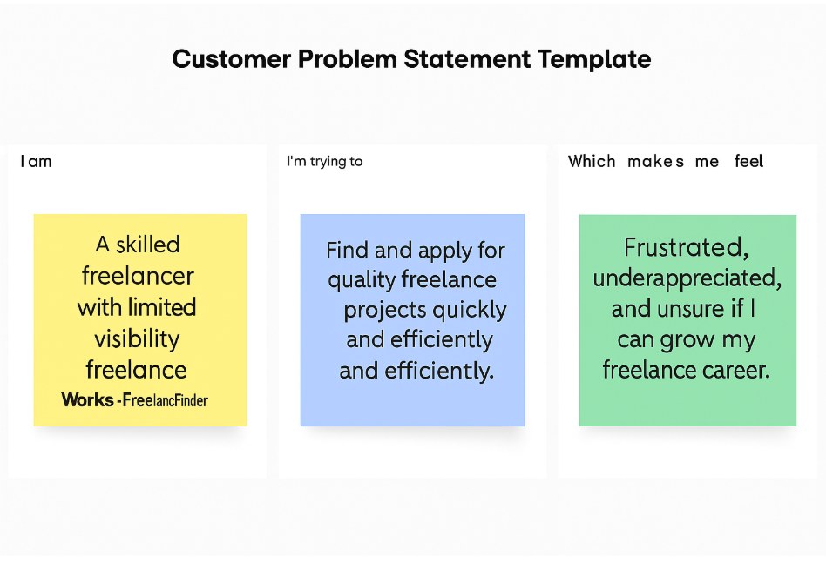

Reference: <https://miro.com/templates/customer-problem-statement/>

|  |  |  |  |  |  |
| --- | --- | --- | --- | --- | --- |
| **Problem Statement (PS)** | **I am (Customer)** | **I’m trying to** | **But** | **Because** | **Which makes me feel** |
| PS-1 | a skilled freelancer with limited visibility | find and apply for quality freelance projects quickly and efficiently | most platforms are overcrowded or don’t match me with the right projects | their filters and recommendations are generic and not skill-based | frustrated, underappreciated, and unsure if I can grow my freelance career |
| PS-2 | a business owner or startup founder | hire reliable freelance talent for one-time or recurring tasks | platforms are cluttered and offer little trust or insight into a freelancer’s performance | I don’t have time to vet candidates manually, and communication tools are often disjointed | overwhelmed, skeptical about value, and worried about wasting money and time |